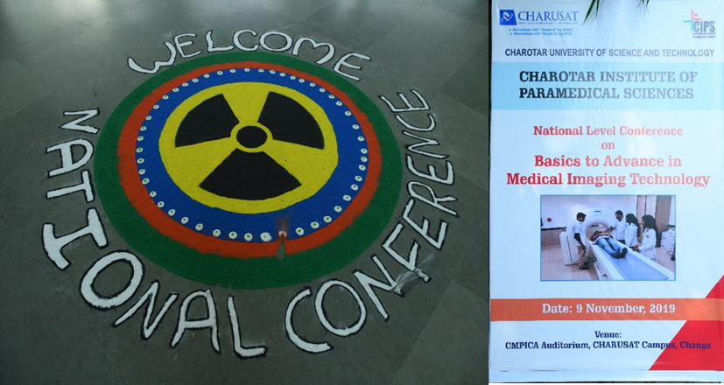

Figure 1: November 9, 2019 - "Rangoli “prepared by the students for the Conference event



Figure 2: November 9, 2019 - Conference Poster on the entrance of the University gate

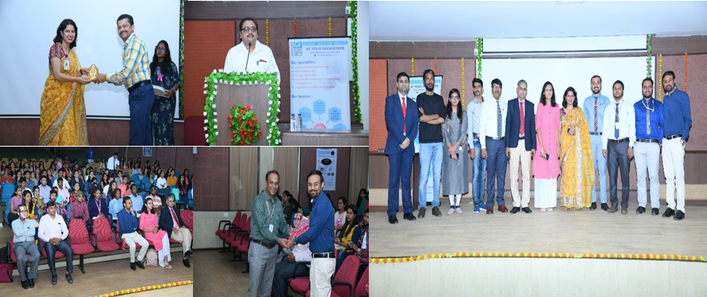

Figure 3: November 9, 2019 - Group photograph taken at the end of the session

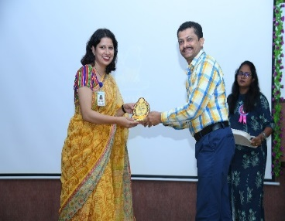

Figure 4: November 9,2019 - Mrs. Dolly Sharma felicitating the speaker Mr. Kalpesh Parikar by handing the Token of Appreciation

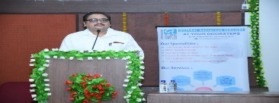

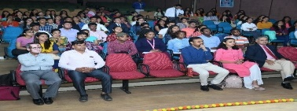

Figure 5: November 9, 2019 - Dr. Deepak V. Mehta delivering the talk on Recent Advancement in Medical Imaging Technology

Figure 6: November 9, 2019 - Photograph of the Delegates taken during the Scientific talk

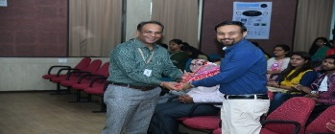

Figure 7: November 9, 2019 - Dr. Darshan Patel, Principal CIPS felicitating Dr. Sunny Mishra by handing the token of appreciation after delivering the Scientific Talk